Directions: Peter Piper is a proper noun and needs to be capitalized. Use the Shift Key to capitalize P in Peter and P in Piper.

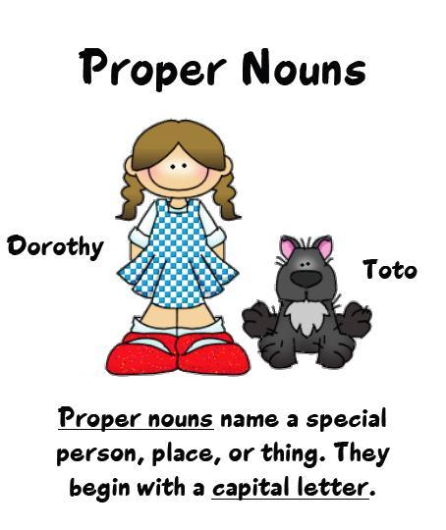

peter piper
peter piper picked a peck of pickled peppers.
Did peter piper pick a peck of pickled peppers?
If peter piper picked a peck of pickled peppers,
where's the peck of pickled peppers peter piper picked?

